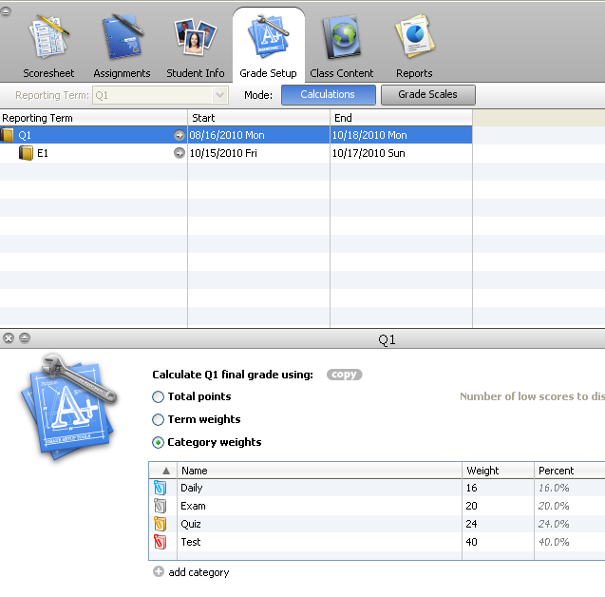
Grade Setup for Dillon High School 9 - 12 Quarter Classes
1. Click Grade Setup.
2. Click Q1 or current quarter.

Example
30
10
30
30
30.0%
10.0%
30.0%
30.0%
3. Choose Category Weights.
**There are four (4) categories by default. You can add your own or rename these to meet your needs. The following requirements must be met:

- Highest Category Weight can be no more than 30%.
- Should have at least 4 Categories.
- Should have at least 4 grades in each category per nine weeks.

- Click the +Add Category to add these as shown in the example and to put in the correct weights you are using. Category Weights should be consistent with each subject and grade level for Q1, Q2, Q3, & Q4.

- Your nine weeks exam (if one is given) will need to be one of the categories and will consist of only the exam grade (shown in example) and weighted appropriately. E1 bucket is not used for the quarter classes.

- You will need to do this for each class and each quarter. **New Feature: See handout for Copying Q1 Setup and Final Grade Setup.

